OSS praticals:

1. Joomla

* Install apache server: apt install apache2
* Restart it: systemctl start apache2
* Install php modules :

apt install php php-xml php-mysql php-mbstring php-zip php-soap php-sqlite3 php-curl php-gd php-ldap php-imap php-common

* Install mysql server: apt install mysql-server
* Go to mysql server and do as below:

1. mysql -u root -p
2. Enter password: Rutu@0204
3. create database joomla;
4. use joomla;
5. create user ‘Rutu369’@localhost identified by ‘Rutuja@02042003’
6. grant all privileges on joomla.* to ‘Rutu369’@localhost;
7. flush privileges;
8. exit

* Now change your dir to cd /var/www/
* Create a joomla dir: mkdir joomla
* cd joomla;
* Install joomla in curr dir using below command in terminal:

wget <https://downloads.joomla.org/cms/joomla4/4-2-3/Joomla_4-2-3-Stable-Full_Package.zip?format=zip>

* unzip [Joomla_4-2-3-Stable-Full_Package.zip?format=zip](https://downloads.joomla.org/cms/joomla4/4-2-3/Joomla_4-2-3-Stable-Full_Package.zip?format=zip)
* Provide necessary permissions to joomla dir

chown -R www-data. ./

chmod -R 755 ./

* Edit the config file of joomla

nano /etc/apache2/sites-available/joomla.conf

Paste below content in it:

<virtualhost *:80>

servername [www.rutujajoomla.com](http://www.rutujajoomla.com)

documentroot /var/www/joomla

</virtualhost>

* Disable the default site:

a2dissite 000-default.conf

* Enable the joomla site

a2ensite joomla.conf

* Enable rewrite mod

a2enmod rewrite

* Restart the apache server

systemctl restart apache

* Next go to joomla configuration page -> enter details and configure database by providing details that were used fro mysql database creation
* Checkout the site

**\*\*Updated runnable steps of joomla\*\***

1. Joomla-

<https://youtu.be/Eak9TmaaLII?si=Y626thk149CN46Ai>

sudo apt install apache2 -y

sudo systemctl start apache2

sudo systemctl enable apache2

sudo systemctl status apache2

sudo apt install php libapache2-mod-php php-dev php-bcmath php-intl php-soap php-zip php-curl php-mbstring php-mysql php-gd php-xml -y

sudo php -v

sudo apt install mariadb-server -y

If this command not is not working then first run this

**sudo apt install mariadb-server-10.3=1:10.3.38-0ubuntu0.20.04.1**

Then run above install command

systemctl start mariadb

systemctl enable mariadb

systemctl status mariadb

mysql:

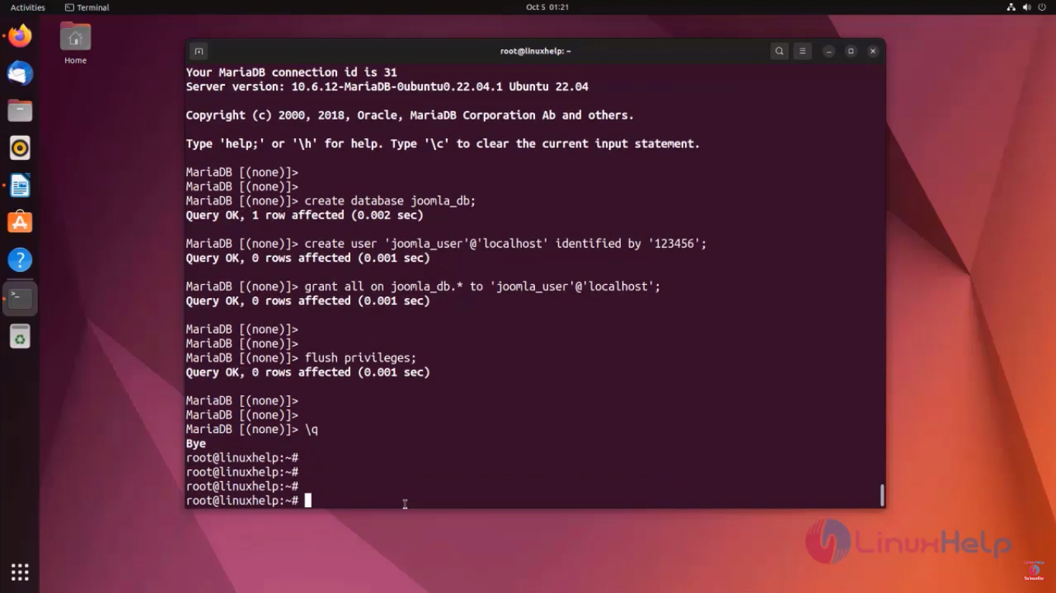

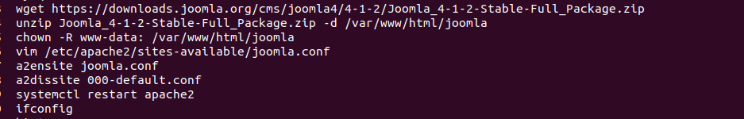

Paste below content in joomla.conf:

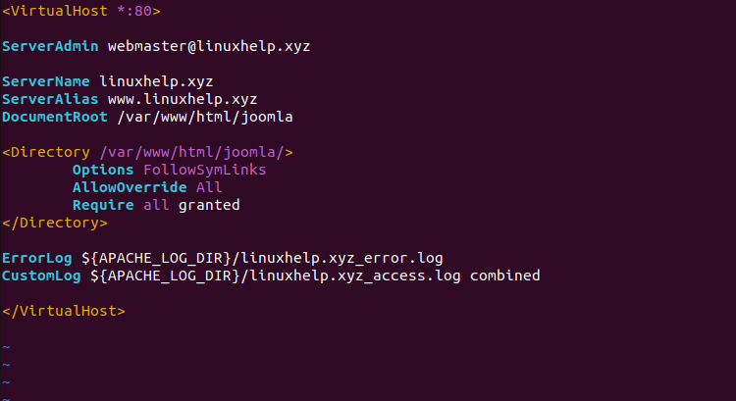

Now go to firefox browser and type your machine IP address and press enter

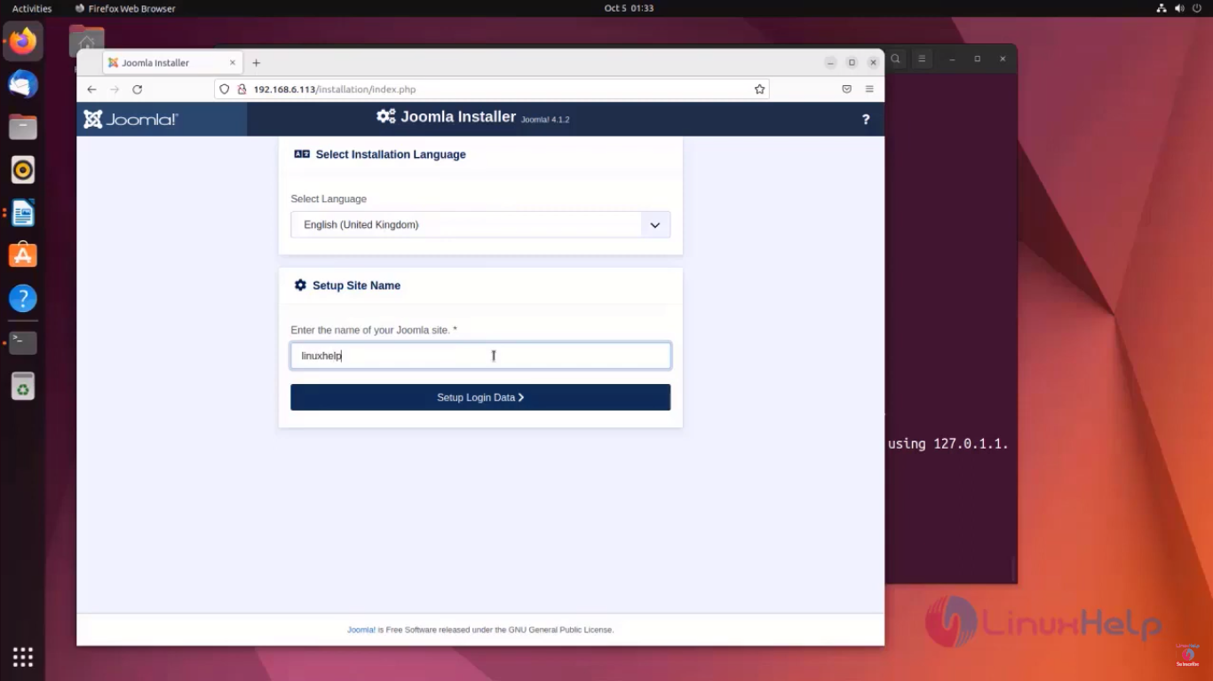

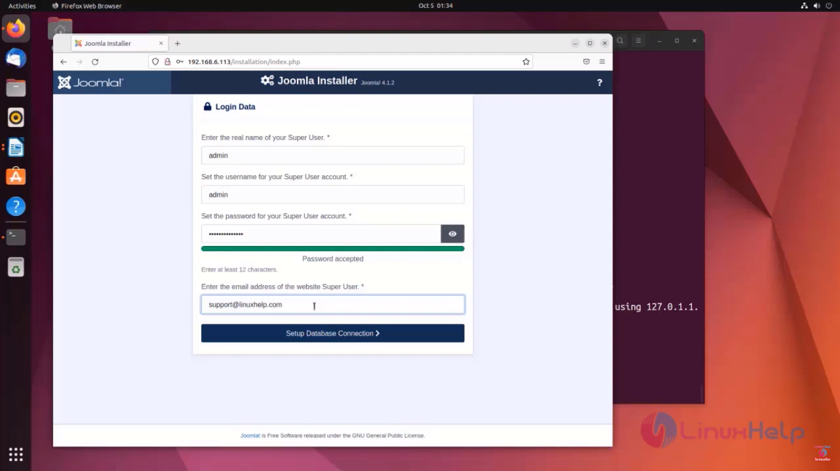

Here password is:Passed@12345

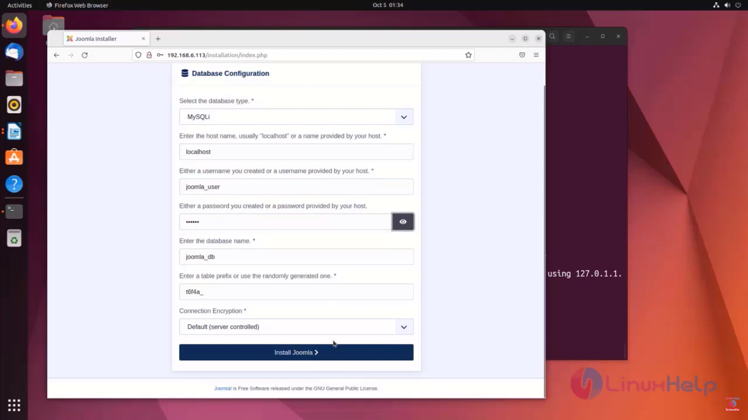

Here password for database configuration is 123456

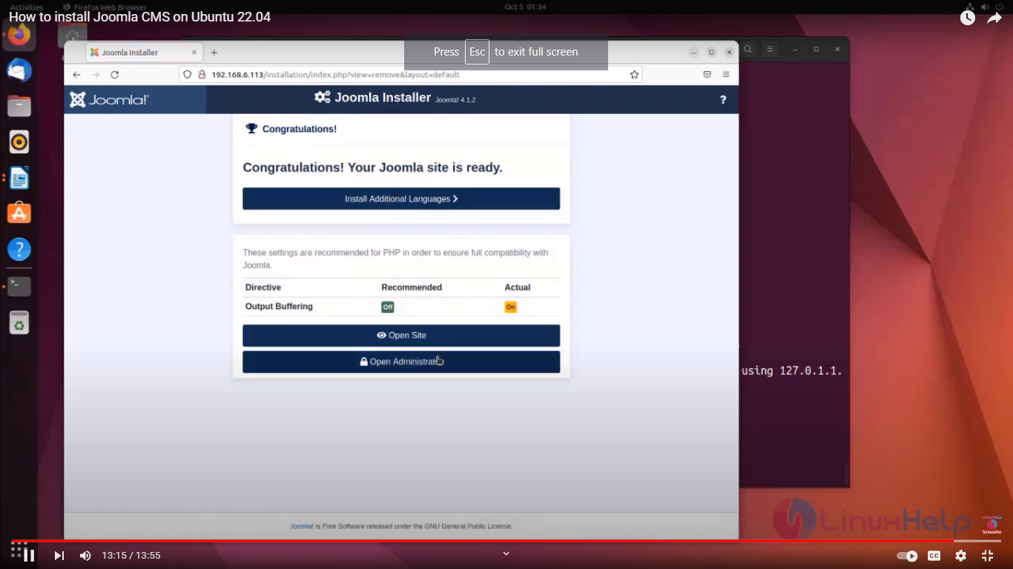

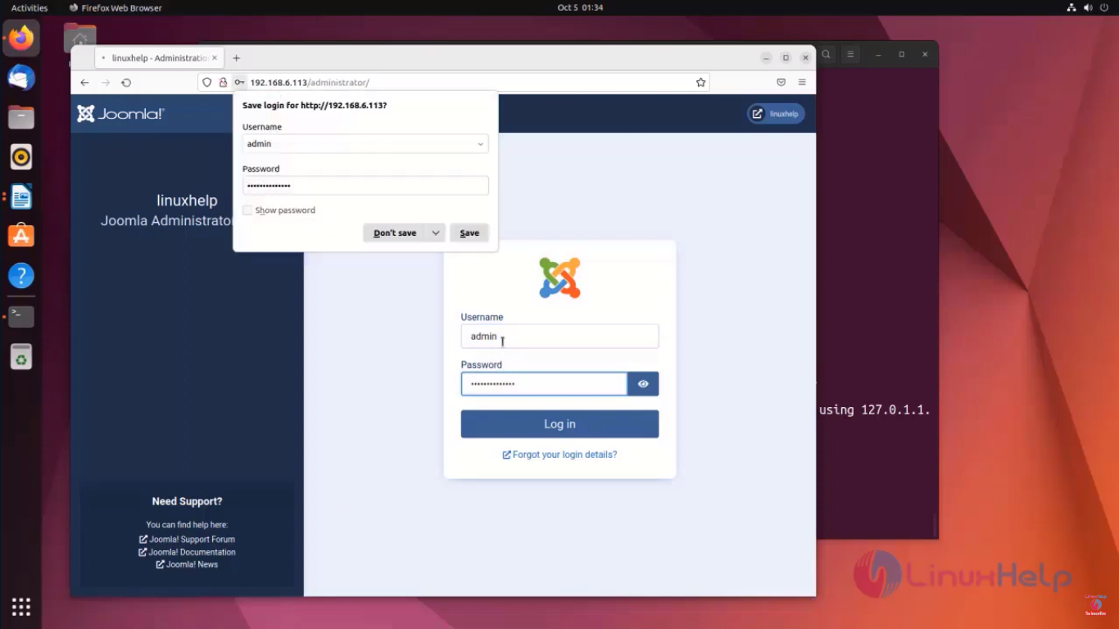

**2. Bugzilla**

https://bugzilla.readthedocs.io/en/latest/installing/quick-start.html

[Official document](https://bugzilla.readthedocs.io/en/latest/installing/quick-start.html) 👍

**3. Rpm Package management**

**Steps:**

**Take a fedora CONTAINER**

**Commands**

**$docker run -it fedora**

**$cd /root**

**Steps:**

1. **Install rpm-build package ( This package holds the scripts and exe programs to pull the rpm packages using rpm package manager)**

**$yum install rpm-build rpmdevtools -y**

1. **Very imp -> move to /root folder first then do following process**
2. **Create the dir structure in curr dir (inside rpmbuild -> create below 5 dir )**

**$rpmbuild**

**rpmbuild/**

* **BUILD: (It stores the source code of program whose package is to be built)**
* **RPMS: (Used to** (Built RPM packages for different architectures) )
* **SOURCES: (stores all tar.gz rpm source files)**
* **SPECS: (Its a location where we create the rpm package config file)**
* **SRPMS: (Stores all srpms files for curr rpm package)**

1. **Create a folder at rpmbuild dir level and then 2 files inside it**

**$mkdir format-1.0**

**$cd format-1.0**

**$nano format.conf -> add random text “this is a config file for rpm package”**

**$nano format.txt -> add random text “this is the document file for given rpm”**

(Save and quit-> move back the to parent dir)

1. Create the tar.gz version of the dir “format-1.0

$tar czvf format-1.0.tar.gz format-1.0

$mv format-1.0.tar.gz rpmbuild/SOURCES/

(Move this format.tar.gz file to rpm/SOURCES/ dir)

1. Move to rpmbuild/SPECS dir to create a config file for rpm package

$cd rpmbuild/SPECS/

1. Create the config file “format.spec” using below command

$rpmdev-newspec format.spec

1. Modify the contents of this file using nano -> This file is useful to create the rpm env

$nano format.spec

1. Replace the file contents with below content:

**Name: format**

**Version: 1.0**

**Release: 1.1**

**Summary: Testing...**

**License: GPL**

**URL: https://github.com/rutuja369/Cpp/blob/main/hello.cpp**

**Source0: format-1.0.tar.gz**

**BuildArch: noarch**

**%description**

**my first rpm package**

**%build**

**cat > format.sh << EOF**

**#!/bin/bash**

**date**

**cal**

**EOF**

**%install**

**mkdir -p %{buildroot}/usr/bin**

**mkdir -p %{buildroot}/yahoo**

**install -m 755 format.sh %{buildroot}/usr/bin/format.sh**

**cp /root/format-1.0/* %{buildroot}/yahoo/**

**%clean**

**rm -rf %{buildroot}**

**%files**

**/usr/bin/format.sh**

**/yahoo/format.txt**

**/yahoo/format.conf**

**%changelog**

**\* Thu Dec 14 2023 Super User**

**-**

1. **Run the command to exe this config file**

**$ rpmbuild -ba format.spec**

**(here -ba -> build all both bin files and src rpm)**

**NOTE: after executing this cmd it should end exe with a “exit 0” status**

1. **Your new rpm package will be created in rpmbuild/RPMS/noarch/**
2. **Now you need to install this package staying in same dir -> rpmbuild/RPMS/noarch**

**$rpm -ivh format-1.0.noarch.rpm**

1. **Now check ls /**

**A yahoo dir is created move into it by navigating to cd /**

**$ cd /**

**$ format.sh ( it gives the date and calender format which was mentioned in the config file format.spec )**

1. **To checkout your document and src files move to yahoo dir**

**$ cd yahoo**

**$ ls**

**Checkout the format.conf and format.txt files**

**4. Debian package management**

**Step 1: Set Up the Directory Structure**

**calc**

**└── calculator**

**├── DEBIAN**

**│ └── control**

**├── usr**

**│ └── bin**

**│ └── executablefile**

Open a terminal and navigate to the location where you want to create the Debian package.

Create a calc folder

Inside this calc folder create another folder , name it DEBIAN

# Create a directory named "calculator"

--mkdir calculator

# Navigate to the " calculator " directory

--cd calculator

# Create a directory named "DEBIAN" inside " calculator "

--mkdir DEBIAN

**Step 2: Create the Control File**

Now, create the control file inside the DEBIAN directory. You can use a text editor like nano or vim. Here, I'm using nano:

--nano DEBIAN/control

Inside the text editor, add the following control file information:

Package: calculator

Version: 1.0

Section: custom

Priority: optional

Architecture: all

Essential: no

Installed-Size: 1024

Maintainer: ShikhaChoudhari

Description: Display String.

**Step 3: Create Additional Directories**

Now, create the additional directories required for the Debian package:

# Inside "calculator" directory, create "usr" directory

--mkdir -p usr/bin

**Step 4: Write a Simple cpp Program**

Inside the **usr/bin** directory, you can create a simple cpp program. Let's create a file named **calc**:

--nano usr/bin/calc.cpp

Write a simple cpp program in the editor:

#include <iostream>

using namespace std;

int main() {

    char operation;

    float num1, num2;

    cout << "Enter operator (+, -, *, /): ";

    cin >> operation;

    cout << "Enter two numbers: ";

    cin >> num1 >> num2;

    switch (operation) {

        case '+':

            cout << "Result: " << num1 << " + " << num2 << " = " << num1 + num2;

            break;

        case '-':

            cout << "Result: " << num1 << " - " << num2 << " = " << num1 - num2;

            break;

        case '*':

            cout << "Result: " << num1 << " * " << num2 << " = " << num1 * num2;

            break;

        case '/':

            if (num2 != 0)

                cout << "Result: " << num1 << " / " << num2 << " = " << num1 / num2;

            else

                cout << "Error! Division by zero is not allowed.";

            break;

        default:

            cout << "Error! Invalid operator.";

            break;

    }

    return 0;

}

Save and exit the text editor.

**Step 5: Compile and run the cpp Program**

Compile the cpp program using the command:

-- g++ calc.cpp -o calc

--./calc

**Step 6: Create the Debian Package**

Now, it's time to create the Debian package using the **dpkg-deb** command. Ensure that the **build-essential** package is installed on your system:

--sudo apt-get install build-essential

Then, build the Debian package:

--dpkg-deb --build calculator

**Step 7: Install the Debian Package**

Once the package is built, you can install it on your system:

(here before installing package)

--sudo dpkg -i calculator.deb

**Step 8: Run the Program**

After installation, you can run your program:

--calc

**\*Docker: Write a C program to create singly linked list and containerize it.**

I] Singlyll.cpp

#include <bits/stdc++.h>

using namespace std;

class Node {

public:

int data;

Node* next;

Node(int val){

this->data = val;

this->next = NULL;

}

};

/* Algorithm to insert element at the head of the list

1. Create a new node with the data

2. Make next of new node as head and previous as NULL

3. Move the head to point to new node

*/

void insertAtHead(Node* &head, int val){

Node* new_node = new Node(val);

new_node->next = head; //for adding at the start our new node would be new head

head = new_node;

}

/* Algorithm to insert element after given position

1. Create a new node with the data

2. Make next of new node as next of prev node

3. Make prev node as next of new node

*/

Node* insertAfter(Node* head, int new_val, int position){

if(position == 0){

Node* a = new Node(new_val);

a->data = new_val;

a->next = head;

return a;

}

else{

int i;

Node* a = head;

for(i = 1; i < position; i++)

a = a->next;

Node* tmp = new Node(new_val);

tmp->data = new_val;

tmp->next = a->next;

a->next = tmp;

return head;

}

}

/* Algorithm to insert element at the end of the list

1. Create a new node with the data

2. Move the last node to point to new node

3. Make the new node as last node

*/

void insertAtEnd(Node* &head, int val){

Node* new_node = new Node(val);

if(head==NULL){ // if list is empty then new node should be 1st element of the list i.e. it will be the head node.

head = new_node;

return;

}

Node* temp = head; //temp variable to not tamper with the values of head

while(temp->next != NULL){

temp = temp->next;

}

temp->next = new_node; // when temp cha next is NULL temp will bew out of while loop n then we set temp cha next to our new node

}

/* Algorithm to search an element in the list

1. Move the current to point to head

2. If current is NULL then the element is not present in the list

3. If current is not NULL then compare the data of current with the element to be searched

4. If the data is equal then return the current

5. If the data is not equal then move the current to point to next of current

*/

bool search(Node* head, int val){

Node* current = head; // Initialize current

while (current != NULL)

{

if (current->data == val)

return true;

current = current->next;

}

return false;

}

/* Algorithm to delete an element from the list

1. Move the current to point to head

2. If current is NULL then the element is not present in the list

3. If current is not NULL then compare the data of current with the element to be deleted

4. If the data is equal then make the next of current as head

5. If the data is not equal then move the current to point to next of current

*/

void deleteNode(Node* &head, int val){

Node* temp = head;

Node* prev = NULL;

if (temp != NULL && temp->data == val) // If head node itself holds the key to be deleted

{

head = temp->next; // Changed head

delete temp; // free old head

return;

}

else{ // Else Search for the key to be deleted,

while (temp != NULL && temp->data != val)

{

prev = temp; //keep track of the previous node as we need to change 'prev->next' */

temp = temp->next;

}

if (temp == NULL) // If key was not present in linked list

return;

prev->next = temp->next; // Unlink the node from linked list

delete temp; // Free memory

}

}

/* Algorithm to print the list

1. Move the current to point to head

2. If current is NULL then the list is empty

3. If current is not NULL then print the data of current and move the current to point to next of current

*/

void printList(Node* n) //to print the linked list

{

if(n != NULL) {

cout << n->data << " ";

printList(n->next);

}

}

// Driver code

int main()

{

Node* head = NULL;

int choice, data, position;

while(1){

cout<<"\n 1.Insert element at the end";

cout<<"\n 2.Insert element after the :";

cout<<"\n 3.Insert element at the start";

cout<<"\n 4.Search for the element in the list";

cout<<"\n 5.Delete node in a list";

cout<<"\n 6.Exit";

cout<<"\n Enter your choice: ";

cin>>choice;

if(choice>5){

break;

}

switch(choice){

case 1:

cout<<"\n Enter data to be inserted at the end: ";

cin>>data;

insertAtEnd(head, data);

printList(head);

break;

case 2:

cout<<"\n Enter data to be inserted : ";

cin>>data;

cout<<"\n Enter index at which element is to be inserted: ";

cin>>position;

insertAfter(head, data, position);

printList(head);

break;

case 3:

cout<<"\n Enter data to be inserted at the start: ";

cin>>data;

insertAtHead(head, data);

printList(head);

break;

case 4:

cout<<"\n Enter data to be searched : ";

cin>>data;

search(head, data)? cout<<"Found" : cout<<"Not found";

break;

case 5:

cout<<"\n Enter element to be deleted : ";

cin>>data;

deleteNode(head, data);

printList(head);

break;

}

}

return 0;

}

II] Dockerfile

# Use a lightweight base image

FROM gcc:latest

# Set the working directory inside the container

WORKDIR /app

# Copy the C++ source code into the container

COPY . .

# Compile the C++ code

RUN g++ -o singlyll singlyll.cpp

# Specify the command to run your application

CMD ["./singlyll"]

Commands:

sudo docker build -t mycppapp .

sudo docker run -it mycppapp

**Server Configurations:**

1. **Telnet:**

<https://youtu.be/Mszf9mAY1D8?si=l8NspUDXoLCduFGr>

Steps: For Server

1. Install telnet

$sudo apt-get install xinetd telnetd

1. Edit “/etc/inetd.conf” using nano and add following line in it and save

**telnet stream tcp nowait telnetd /usr/sbin/tcpd /usr/sbin/in.telnetd**

1. Now edit “/etc/xinetd.conf” file using nano and add below content in it and save

**instances=60**

**log_type =SYSLOG authpriv**

**log_on_success= HOST PID**

**log_on_failure= HOST**

**cps= 25 30**

1. Restart the telnet server using

$sudo /etc/init.d/xinetd restart

Steps: For Client (another pc)

1. Run this command

$telnet <ip_of_server_pc>

1. Next login using server ka username and password -> done

**Error:**

**telnet 10.40.6.121**

**Trying 10.40.6.121...**

**Connected to 10.40.6.121.**

**Escape character is '^]'.**

**Connection closed by foreign host.**

**Step1: Install Telnet Server:**

**sudo apt-get update**

**sudo apt-get install openbsd-inetd**

**Step2:**

**Check if Telnet Line is Uncommented:**

**Edit the /etc/inetd.conf file and make sure the line for Telnet is uncommented (remove the # at the beginning of the line). The Telnet line should look like this:**

**telnet stream tcp nowait telnetd /usr/sbin/tcpd /usr/sbin/in.telnetd**

**Step3: Restart the inetd Service:**

**sudo systemctl restart openbsd-inetd**

**Last step:**

**telnet localhost(ip address)**

**2. FTP**

**$ apt-get update**

**$ apt-get install vsftpd**

**$ nano /etc/vsftpd.conf**

**Make the changes in this file**

**Uncomment–**

**anonymous_enable=NO**

**local_enable=YES**

**write_enable=YES**

**ascii_upload_enable=YES**

**ascii_download_enable=YES**

**Add at last**

**user_sub_token=$USER**

**local_root=/home/$USER/ftp**

**pasv_min_port=10000**

**pasv_max_port=10100**

**userlist_deny=NO**

**$ ufw allow from any port 20,21,10000:10100 proto tcp**

Allow traffic from these ports

$s**udo adduser abc –** create a new user set password for it and enter the information for user

$**mkdir /home/abc/ftp-** create a new folder for “abc” user

**$ sudo chown nobody:nogroup /home/abc/ftp**

**$ chmod a-w /home/abc/ftp**

**$ mkdir /home/abc/ftp/upload**

**$ sudo chown abc:abc /home/abc/ftp/upload**

**$echo "My FTP Server" | sudo tee /home/abc/ftp/upload/demo.txt**

**$ echo "abc" | sudo tee /etc/vsftpd.userlist (creating the userlist and adding abc to it)**

**$ sudo systemctl restart vsftpd (restarting vsftpd)**

**Now login with the new created user in another terminal**

**To login user**

**$ su - abc**

**$ftp localhost**

Then enter the username and password to login to ftp

**$ls**

**$ put file.txt**

**$ get file1.txt //it uploaded by server on ftp**

**Docker Practicals:**

**Docker Installation:** [**https://docs.docker.com/engine/install/ubuntu/**](https://docs.docker.com/engine/install/ubuntu/)

**Pushing Image to HUB:**

1. docker login --username <your_username>
2. docker tag <your_image_name> <your_username>/<your_repo_name>:<tag>
3. docker push <your_username>/<your_repo_name>:<tag>

**Docker Compose Installation:**

**sudo apt-get update**

**sudo apt-get install docker-compose-plugin**

**1. *Docker: Write a python program to perform arithmetic operations and create Docker image accordingly.**

**# arithmetic_operations.py**

**def add(x, y):**

**return x + y**

**def subtract(x, y):**

**return x - y**

**def multiply(x, y):**

**return x * y**

**def divide(x, y):**

**if y != 0:**

**return x / y**

**else:**

**return "Error: Division by zero"**

**if __name__ == "__main__":**

**num1 = float(input("Enter the first number: "))**

**num2 = float(input("Enter the second number: "))**

**print(f"\nResults:")**

**print(f"Sum: {add(num1, num2)}")**

**print(f"Difference: {subtract(num1, num2)}")**

**print(f"Product: {multiply(num1, num2)}")**

**print(f"Quotient: {divide(num1, num2)}")**

**Dockerfile:**

**# Use an official Python runtime as a parent image**

**FROM python:3.9**

**# Set the working directory in the container**

**WORKDIR /app**

**# Copy the current directory contents into the container at /app**

**COPY . /app**

**# Install any needed packages specified in requirements.txt**

**RUN pip install --no-cache-dir -r requirements.txt**

**# Make port 80 available to the world outside this container**

**EXPOSE 80**

**# Define environment variable**

**ENV NAME World**

**# Run arithmetic_operations.py when the container launches**

**CMD ["python", "arithmetic_operations.py"]**

**2. Mount any host dir to container**

**docker run -it -v : <directory-name-on-host>: <directory-name-on-container> <image_name>**

**3. Exposing port**

**docker run -p <host_port>:<container_port> <image_name>**

**4. *Docker: Write a Docker File to pull the Ubuntu with open jdk and write any java application.**

**# Use the official Ubuntu base image**

**FROM ubuntu:latest**

**# Set the working directory in the container**

**WORKDIR /usr/src/app**

**# Update the package lists and install OpenJDK**

**RUN apt-get update && \**

**apt-get install -y openjdk-11-jdk**

**# Copy the Java application JAR file into the container**

**COPY YourJavaApp.jar .**

**# Specify the command to run your application**

**CMD ["java", "-jar", "YourJavaApp.jar"]**

**5.**

1. Create a Docker Compose file:

Create a file named docker-compose.yml **and add the following content:**

**Yaml file:**

**version: '3'**

**services:**

**db:**

**image: mysql:5.7**

**environment:**

**MYSQL_ROOT_PASSWORD: example_root_password**

**MYSQL_DATABASE: mediawiki**

**MYSQL_USER: mediawiki**

**MYSQL_PASSWORD: example_mediawiki_password**

**volumes:**

**- db_data:/var/lib/mysql**

**mediawiki:**

**image: mediawiki**

**environment:**

**MEDIAWIKI_DB_HOST: db**

**MEDIAWIKI_DB_USER: mediawiki**

**MEDIAWIKI_DB_PASSWORD: example_mediawiki_password**

**ports:**

**- "8080:80"**

**volumes:**

**- mediawiki_data:/var/www/html/images**

**volumes:**

**db_data:**

**mediawiki_data:**

2. Run the Docker Compose stack:

Open a terminal in the directory where the docker-compose.yml **file is located and run the following command:**

**docker-compose up -d**

3. Access MediaWiki:

Open a web browser and navigate to http://localhost:8080**. You should see the MediaWiki setup page.**

**Follow the on-screen instructions to complete the MediaWiki installation, providing the necessary information such as the database host (**db**), username (**mediawiki**), password (**example_mediawiki_password**), and database name (**mediawiki**).**

**After the setup, you can access your MediaWiki site at** http://localhost:8080**.**

**4. Stop and remove containers:**

**When you're done, you can stop and remove the containers using the following command:**

**docker-compose down**

6. **\*Docker: Create a LAMP Stack container and host a web application** of your own.

Dir Structure:

docker-compose.yaml

php(folder):

* src

- index.php

- style.css

- Dockerfile

1. Docker compose. Yaml contents:

version: '3.8'

services:

php-apache-environment:

container_name: php-apache

build:

context: ./php

dockerfile: Dockerfile

depends_on:

- db

volumes:

- ./php/src:/var/www/html/

ports:

- 8000:80

db:

container_name: db

image: mysql

restart: always

environment:

MYSQL_ROOT_PASSWORD: MYSQL_ROOT_PASSWORD

MYSQL_DATABASE: MYSQL_DATABASE

MYSQL_USER: MYSQL_USER

MYSQL_PASSWORD: MYSQL_PASSWORD

ports:

- "9906:3306"

phpmyadmin:

image: phpmyadmin/phpmyadmin

ports:

- '8080:80'

restart: always

environment:

PMA_HOST: db

depends_on:

- db

1. index.php

<?php

//These are the defined authentication environment in the db service

// The MySQL service named in the docker-compose.yml.

$host = 'db';

// Database use name

$user = 'MYSQL_USER';

//database user password

$pass = 'MYSQL_PASSWORD';

//database name

$mydatabase = 'MYSQL_DATABASE';

$conn = new mysqli($host, $user, $pass, $mydatabase);

$errors = [];

$id = 0;

$first_name = '';

$last_name = '';

$gender = '';

$email = '';

$bio = '';

$timestamp = '';

if($_SERVER['REQUEST_METHOD'] === 'POST'){

// validate form

$first_name= $_REQUEST['first-name'];

$last_name = $_REQUEST['last-name'];

$gender = $_REQUEST['gender'];

$email = $_REQUEST['email'];

$bio = $_REQUEST['bio'];

$timestamp = date('Y-m-d H:i:s');

if(!$first_name){

$errors[] = 'Enter First Name';

}

if(!$last_name){

$errors[] = 'Enter Last Name';

}

if(!$gender){

$errors[] = 'Enter Gender';

}

if(!$email){

$errors[] = 'Enter Email';

}

if(!$bio){

$errors[] = 'Enter Bio';

}

if(empty($errors)){

$sql = "INSERT INTO form_details VALUES ('$id','$first_name','$last_name','$gender','$email','$bio','$timestamp')";

if(mysqli_query($conn, $sql)){

} else{

echo "ERROR: Hush! Sorry $sql. "

. mysqli_error($conn);

}

$first_name = '';

$last_name = '';

$gender = '';

$email = '';

$bio = '';

$timestamp = '';

$id+=1;

}

}

mysqli_close($conn);

?>

<!doctype html>

<html lang="en">

<head>

<meta charset="utf-8">

<meta name="viewport" content="width=device-width, initial-scale=1">

<title>INFO FORM</title>

<link href="https://cdn.jsdelivr.net/npm/bootstrap@5.2.2/dist/css/bootstrap.min.css" rel="stylesheet" integrity="sha384-Zenh87qX5JnK2Jl0vWa8Ck2rdkQ2Bzep5IDxbcnCeuOxjzrPF/et3URy9Bv1WTRi" crossorigin="anonymous">

<link href="style.css" rel="stylesheet">

</head>

<body>

<?php if(!empty($errors)): ?>

<div class="alert alert-danger">

<?php foreach($errors as $error):?>

<div><?php echo $error?></div>

<?php endforeach;?>

</div>

<?php endif;?>

<form method="post" class="container mt-5 extra">

<h1 class="title">Form Details</h1>

<div class="mb-3">

<label for="first-name" class="form-label">First Name</label>

<input name="first-name" type="text" class="form-control" placeholder="Enter First Name" value="<?php echo $first_name ?>">

</div>

<div class="mb-3">

<label for="last-name" class="form-label">Last Name</label>

<input name="last-name" type="text" class="form-control" placeholder="Enter Last Name" value="<?php echo $first_name ?>">

</div>

<div class="mb-3">

<label for="gender" class="form-label">Gender</label>

<input name="gender" type="text" class="form-control" placeholder="Male | Female | Others" value="<?php echo $gender?>">

</div>

<div class="mb-3">

<label for="email" class="form-label">Email address</label>

<input name="email" type="email" class="form-control" value="<?php echo $email?>">

<div class="form-text">We'll never share your email with anyone else.</div>

</div>

<div class="mb-3">

<label for="bio" class="form-label">Bio</label>

<textarea name="bio" class="form-control" value="<?php echo $bio?>"></textarea>

</div>

<button type="submit" class="btn btn-primary mb-200">Submit</button>

</form>

<script src="https://cdn.jsdelivr.net/npm/bootstrap@5.2.2/dist/js/bootstrap.bundle.min.js" integrity="sha384-OERcA2EqjJCMA+/3y+gxIOqMEjwtxJY7qPCqsdltbNJuaOe923+mo//f6V8Qbsw3" crossorigin="anonymous"></script>

</body>

</html>

1. style.css

@import url('https://fonts.googleapis.com/css2?family=Roboto&display=swap');

.title{

font-family: 'Roboto', sans-serif;

}

.container{

margin-bottom: 50px;

}

.btn{

width: 100%;

}

Dockerfile:

FROM php:8.0-apache

RUN docker-php-ext-install mysqli && docker-php-ext-enable mysqli

RUN apt-get update && apt-get upgrade -y

Flask application hello world dockerization

Directory structure

project_directory/

│

├── app.py

├── requirements.txt # <- Create this file here

└── Dockerfile

Install flask

**$pip install Flask**

**app.py file**

from flask import Flask

app = Flask(__name__)

@app.route('/')

def hello():

return 'Hello, World!'

if __name__ == '__main__':

app.run(host='0.0.0.0', port=5000)

**requirements.txt file**

flask

**Dockerfile**

FROM python:3.12.1-alpine3.18

WORKDIR /app

COPY . /app

RUN pip install -r requirements.txt

EXPOSE 5000

CMD ["python", "app.py"]

$docker build -t my-flask-app .

$docker run -p 5000:5000 my-flask-app

Access on browser localhost:5000

**Media wiki**

<https://www.mediawiki.org/wiki/Manual:Running_MediaWiki_on_Debian_or_Ubuntu>

Video

$ sudo apt-get install php5-intl

$apt-get install php5-gd

$sudo apt-get install apache2 mariadb-server php php-mysql libapache2-mod-php php-xml php-mbstring

$apt-get install texlive php5-xcache

$service apache2 restart

$wget <https://releases.wikimedia.org/mediawiki/1.40/mediawiki-1.40.1.tar.gz>

extract in your Web directory

$ tar -xvzf /tmp/mediawiki-[1.40.1](https://releases.wikimedia.org/mediawiki/1.40/mediawiki-1.40.1.tar.gz).tar.gz

$mv mediawiki-1.40.1/* /var/www/html

$mysql -u root -p

Create database my_wiki;

Use my_wiki;

create user ‘Rutu369’@localhost identified by ‘Rutuja@02042003’

grant all privileges on my_wiki.* to ‘Rutu369’@localhost;

flush privileges;

Open browser and give ip_address/ index.php then click set up the wiki select language and continue

On terminal…….

$apt-get install php5-mysql

$service apache2 restart

Refresh the page on browser

Fill database info

Database host- localhost

Database name - my_wiki

Fill username and password and click continue

Keep database setting default and click continue

Then create administrator account fill details

On next page keep everything as default just enable **enable file uploads** in images and file upload section

Continue …Continue …Continue …

Download **localsetting.php** file check save file and ok

Open the downloaded file and copy the content

Open terminal

Inside **/var/www/html** create a file **localsettings.php** and paste the copied contents

Open browser

On congratulations page …..

Click on **enter your wiki**

**Click login on upper right corner**

**After login**

**On left corner see the tools…**

8. **\*CMS : Demonstrate the use/features of CMS software: Using Joomla container .**

Crate users and show how Joomla manages web sites for a client. Also implement the working of core features of Joomla.

Compare it with other **CMS** like Druple (on answer sheet)

Certainly! Joomla is a popular content management system (CMS) that allows you to build and manage websites easily. In this example, I'll guide you through the process of setting up Joomla in a Docker container, creating users, and demonstrating some core features.

### Step 1: Install Docker

Make sure you have Docker installed on your machine. You can download and install Docker from the official website: [Docker](https://www.docker.com/).

### Step 2: Set Up Joomla in a Docker Container

Create a new directory for your Joomla project and navigate to it in the terminal.

```bash

mkdir my-joomla-site

cd my-joomla-site

```

Create a `docker-compose.yml` file with the following content:

```yaml

version: '3.3'

services:

joomla:

image: joomla

container_name: my-joomla-container

restart: always

ports:

- "8080:80"

environment:

JOOMLA_DB_HOST: db

JOOMLA_DB_USER: example_user

JOOMLA_DB_PASSWORD: example_password

JOOMLA_DB_NAME: example_db

db:

image: mysql:5.7

container_name: my-mysql-container

restart: always

environment:

MYSQL_DATABASE: example_db

MYSQL_USER: example_user

MYSQL_PASSWORD: example_password

MYSQL_RANDOM_ROOT_PASSWORD: '1'

```

This `docker-compose.yml` file sets up a Joomla container and a MySQL database container. Adjust the environment variables as needed.

Run the containers:

```bash

docker-compose up -d

```

### Step 3: Access Joomla Installation

Open your web browser and go to [http://localhost:8080](http://localhost:8080). Follow the Joomla installation process.

### Step 4: Create Users

After installing Joomla, log in as an administrator and create a new user:

1. Log in to the Joomla administrator panel (usually at [http://localhost:8080/administrator](http://localhost:8080/administrator)).

2. Navigate to "Users" > "Manage" > "Add New User."

3. Fill in the user details and assign appropriate user groups.

### Step 5: Manage Website Content

Explore Joomla's core features for managing website content:

1. **Create Articles:**

- Go to "Content" > "Articles" > "Add New Article."

- Fill in the article details and content.

2. **Manage Menus:**

- Go to "Menus" > "Main Menu."

- Add a new menu item pointing to your article.

3. **Install Extensions:**

- Go to "Extensions" > "Manage" > "Install."

- Install additional extensions for added functionality.

4. **Customize Templates:**

- Go to "Extensions" > "Templates" to manage and customize your site's template.

### Step 6: Explore More Features

Explore Joomla's documentation to learn more about its features and functionalities: [Joomla Documentation](https://docs.joomla.org/Main_Page).

This example provides a basic setup and user management. You can further customize and extend Joomla based on your specific needs.